Mini ACDP programmer

Yanhua Mini ACDP Programming Master support BMW CAS1/CAS2/CAS3/CAS3+/CAS4/CAS4+/FEM/BDC Key Programming by OBD port, no need soldering, which also can read BMW DME ISN by obd, BMW 35080, 35160DO WT EEPROM Read & Write, Fujitsu CPU MB91F Read & Write, Read & Write BMW 35080, 35160DO WT, MQB/MMC Instrument, Refresh BMW Keys and BMW FRM Programming. Work on PC, Android and IOS.

**Yanhua Mini ACDP Programming Master Basic Configuration work on PC/Android/IOS with Wifi**  
  
**Yanhua Mini ACDP Support 93 /24/ 25 / 35/ 95 Series EEPROM in circuit programming (ICP) and on adapter board programming (OBP), and parts of Freescale / NEC MCU in circuit programming (ICP). This host is a necessary basic configuration for other modules.**  
  
**BMW CAS-CAS3+ Key Programming by OBD**   
Read CAS EEPROM  
Add Keys  
Reset Mileage  
Back up or recover CAS  
All keys Lost  
  
**BMW CAS4/CAS4**Read CAS4 EEPROM without soldering/welding  
Add Keys without soldering/welding  
Reset Mileage without soldering/welding  
Back up or recover CAS without soldering/welding  
All keys Lost without soldering/welding  
  
**FEM/BDC**   
All keys lost without soldering/welding  
Add keys without soldering/welding  
Delete Keys without soldering/welding  
Enable/Disable keys without soldering/welding  
Read Key ID  
Repair/Replace FEM Module without soldering/welding  
Reset Mileage without soldering/welding  
  
**Read and Write ISN Code**   
N20(mevd1724, mevd172P, mevd1729), N13(mevd1725, ), N55(mevd172, mevd1726, mevd172G, mevd172S, MEVD17, ), MSV80, MSD81, MSD85, MSD85HY, MSD87, MSV90, MEVD1728(s63), mev1722, med172, mevd1727, dde701_edc17c50, BMSX….  
  
**BMW 35080, 35160DO WT Read & Write**   
Read and write BMW M35080, 35160DO WT etc EEPROM, erase 080DOWQ, 080DOWT, 160DOWQ, 160DOWT, M35128 models.  
  
**Fujitsu CPU MB91F Read & Write Module**  
Supports Honda FIT, Vezel, Fifth generation Hyundai Sonata, Kia K3/K5 etc Fujitsu CPU MB91F series read & write function.   
  
**MQB/MMC Instrument Module**  
Support parts of VDO mileage adjustment of VW MQB platform via OBD,and Passat MMC (NEC D70F3525 + 95320) instrument adjustment after years 2015 by ICP mode.

**Refresh BMW Keys Module )**  
Refresh BMW E chassis/F chassis key to make BMW keys can be used repeatedly.  
  
  
**BMW FRM Programming Module**  
Read and write BMW FRM module (FRM Footwell module) 0L15Y chip EEPROM/FLASH data. Read and write 3M25J chip EEPROM/D-FLASH/P-FLASH data.

**Land Rover Key Programming on KVM 2014-2018**   
Yanhua Mini ACDP Module9 Land Rover Key Programming Support KVM from 2014-2018 Add Key & All Key Lost  
 **Yanhua Mini ACDP Module10 Porsche BCM Key** 1. Free of disassembly, Solderless.   
No need to remove components,   
No need to cut the line, no risk of damage to the BCM computer board.  
2. Set anti-theft data reading and writing, anti-theft data calculation, key programming in one.  
3. The interface board replaces the welding wire, the pin connect with intelligent detection, and the data reading and writing is safe and reliable.  
4. With the key refresh function, No longer afraid of loss caused by key be locked.  
  
**Yanhua Mini ACDP Module11 Clear EGS ISN   
Scope of application:**  
For connecting BMW 6HP/8HP gearbox  
**Functions includes as below:**  
EGS State  
Clear ISN  
Reset Adaptation  
Backup Coding  
Recover Coding  
  
**Yanhua Mini ACDP Highlights:**  
  
Test car NO longer needs engines  
YANHUA car keys programming NO longer need soldering iron  
Car locksmith NO longer needs soldering work.  
The first in the world  
Programming no need soldering  
  
**Yanhua Mini ACDP IMMO/Mileage Programming**  
  
No need to remove chip  
No need soldering  
No need to cut the line  
No need to lift the pin  
  
  
**BMW: CAS4/FEM/BDC/16ODOWT  
Solder-free programming Data safety**  
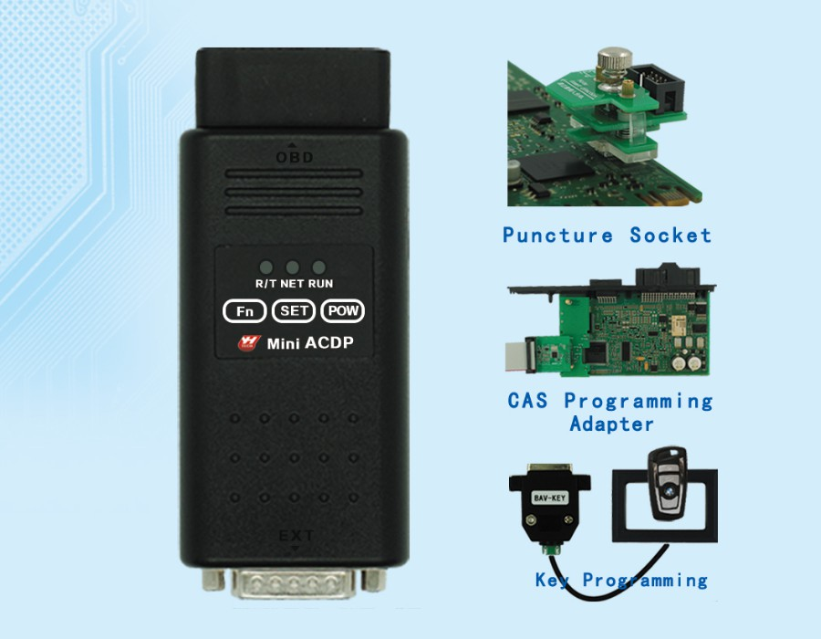  
  
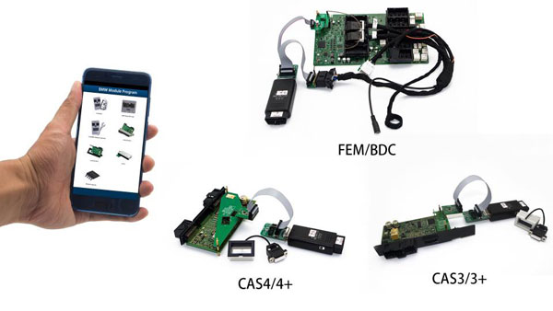  
  
  
  
**ICP: Memory and MCU programming In Circuits  
  
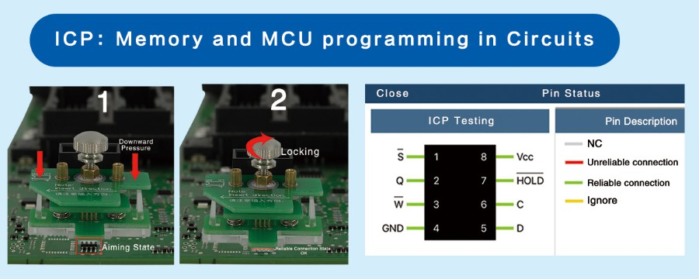**  
  
**MCU programming in Circuits  
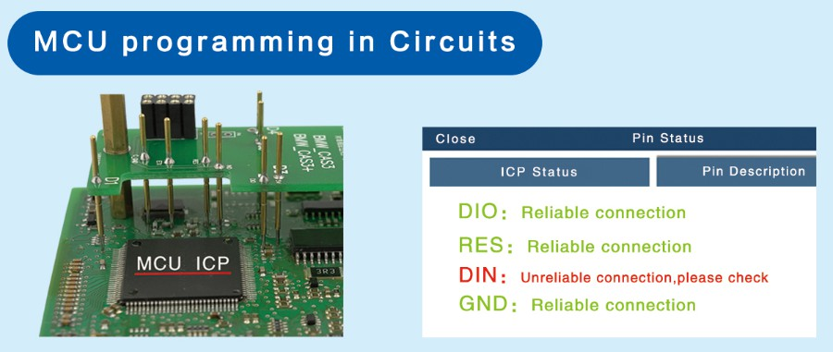**  
  
**Yanhua Mini ACDP Functions**  
  
1. Memory programming:  
Support 93/24/25/35/95 series EEPROM in circuit (ICP)and on board(OBP)programming and parts of Freescale/ NEC MCU in circuit programming(ICP).  
  
2. BMW module programming:  
(1) Support cas1-cas4+and FEM/BDC IMMO key programming, mileage reset, program recovery.  
(2)BMW engine ECU data reading and ISN code reading  
   
3. VW module programming. MMC instrument  
4. Instrument mileage and airbag ECU reset/maintenance is under development.  
5. BENZ. BMW Audi and various models are upgraded successively  
  
**A game changer for BMW Key Programming**  
1. CAS4/CAS4+ Key Programming Without Soldering or removing component.  
2. FEM/BD.C Key Programming without Soldering/Welding  
3. Read ISN Code from OBD Port directly(Partially)  
  
  
  
**Yanhua Mini ACDP Package List:**  
  
1pc x ACDP Programmer Master  
1pc x OBP+ICP adapter  
1pc x Puncture socket  
1pc x P8P ribbon cable  
1pc x 8P cable  
1pc x 20P cable  
1pc x 12V power adapter   
3pcs x paint surface cleaning needles (1.0mm,0.8mm,0.5mm)  
1pc x BAV Key Adapter

**Eraser M35080/M35160 (080D0WQ - 160D0WQ)**

Stand alone M35080 Eeprom eraser with auto-detect.  
It can erase the whole Eeprom including the 16 incremental  
registers. It works on M35080 Eeprom starting from the first generation  
until the last one, including M35160. In this way Eeprom can  
be programmed for countless times.

**Compatible Memory:**  
M35080  
M35080-3  
M35080-6  
M35080 V6  
M35080 VP  
080D0WQ  
M35160  
160D0WQ

Bmw chip eraser

Supports

* 35080 Read/Write EEprom, Erase
* 35080V6 Read/Write EEprom, Erase
* D080DWQ Read/Write EEprom, Erase
* D160DWQ Read/Write EEprom, Erase